Homework 4pt2

COMP 3350

**(4.)**

1. **Memory Address: 0x0040100B**
2. **[Image]** 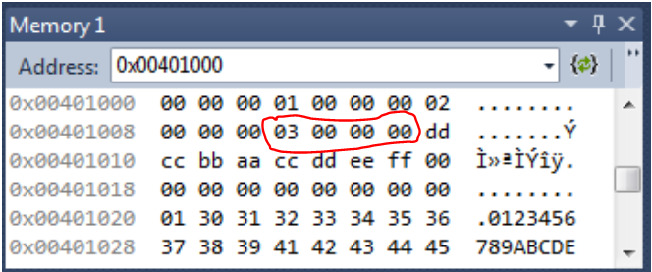
3. **Output: 00000003**

**(5.)**

1. **Memory Address: 0x0040100Fh**
2. **[Image]** 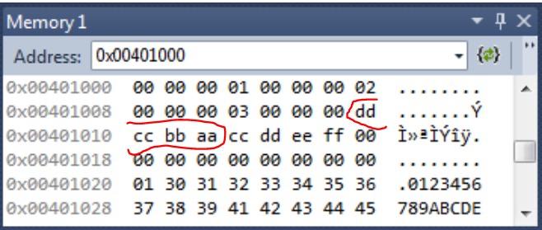
3. **Output: AABBCCDD**

**(6.)**

1. **Memory Address: 0x00401002h**
2. **[image]** 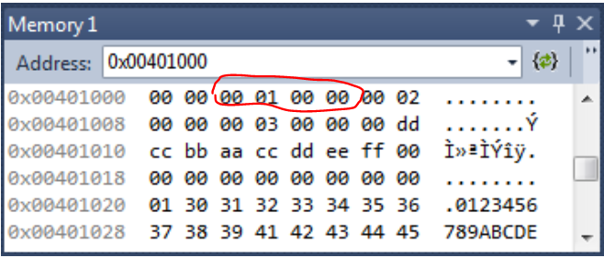
3. **Output: 00000100**

**(7.)**

1. **Memory Address: 0x00401007h**
2. **[Image]** 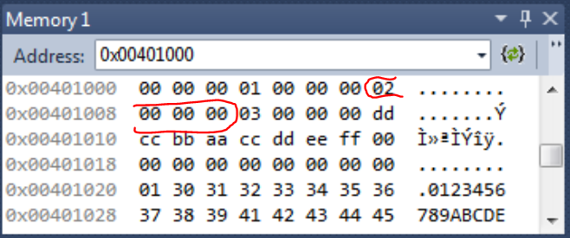
3. **Output: 00000002**